Name: Wee Kar Ghee

Admission number: P7374908

Web API Description

|  |  |  |  |  |
| --- | --- | --- | --- | --- |
| S/N | URL | HTTP Method | POST Body | Result (On success and failure) |
| 1 | /users/login | POST | JSON String of email and password | Verify admin’s credentials using email and password.  On success – message: “username and password checked and admin verified”.  On failure – message:  “wrong email/password and/or not an admin”. |
| 2 | /movie | POST | JSON String of movie details | Add new movie.  On success -message:  movie ‘id number’ has been added.  On Bad request 404- message:  Error Occurred! |
| 3 | /genre | POST | JSON String of genre details | Add new genre.  On success-message:  Genre ‘id number’ has been added.  On Bad request 404- message:  Error Occurred! |
| 4 | /movie=ACTIVE | GET | empty | Retrieve all active screening movies.  On success - results based on 2 months from release_date.  On Bad request 404- message:  Error Occurred! |
| 5 | /movieNameBySubString=A | GET | empty | Retrieve movies based on substring of movie name, sorted in ascending release date.  On success – results with movie name begin with ‘A’ and sorted in ascending release date.  On Bad request 404- message:  Error Occurred! |
| 6 | /genres | GET | empty | Retrieve all genres.  On success – results show all genres.  On Bad request 404- message:  Error Occurred! |
| 7 | /movies | GET | empty | Retrieve all movies.  On success – results show all movies.  On Bad request 404- message:  Error Occurred! |

The Database table downloaded from MySQL in Json file – genres.json, movies.json, users.json

genres table

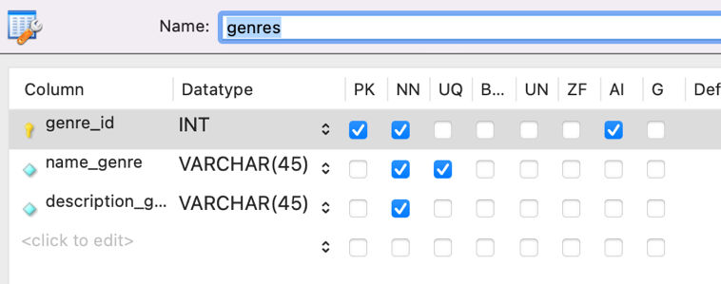

movies table

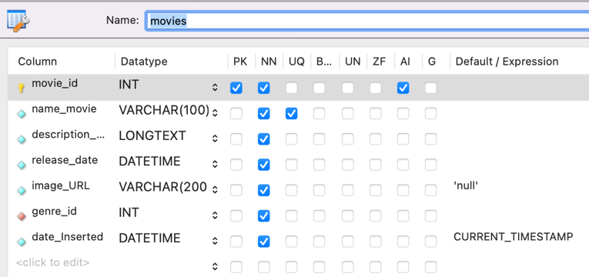

users table

